Youtube link: <https://youtu.be/FneKxcsDmxU>

Hotkeys:

While camera is moving automatically, press B to end movement and control

Press 1 to switch between scenes

This scene uses deferred rendering to create 256 lights where the position and colour are randomly generate which light up the landscape and the 1024 spheres acting as snow. The snow all has initial random positions and will slowly fall until it reaches below 0 on the y axis where it will be reset to the top of the scene.

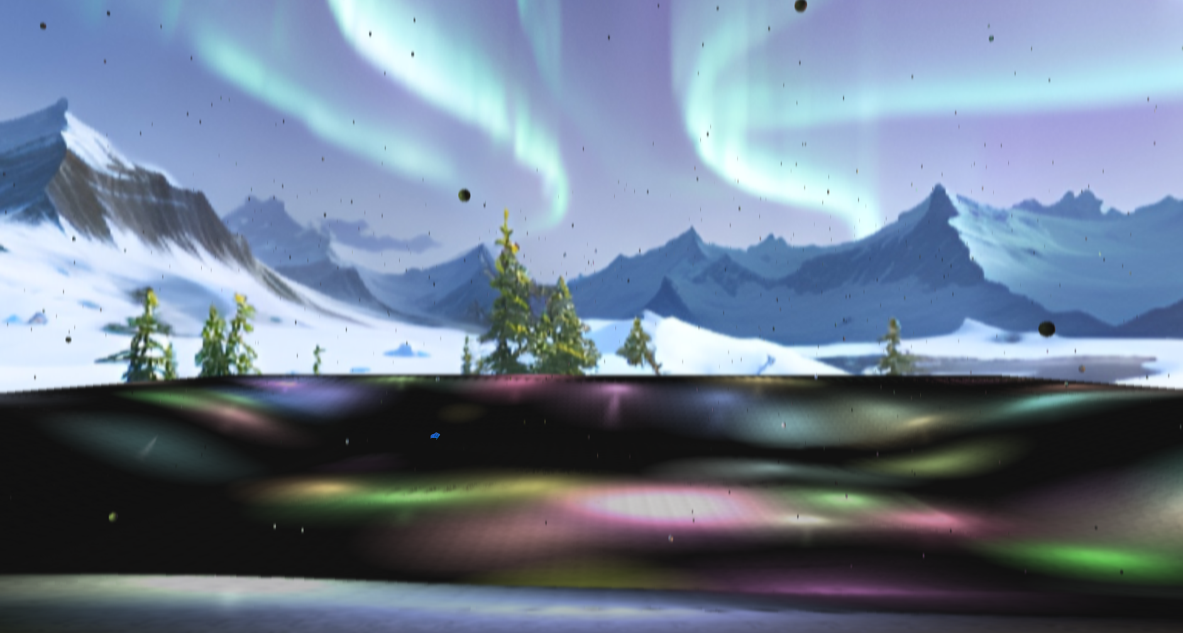

This is a split screen effect created by doing a render pass on both scenes. The passes are stored in buffers and use a dedicated fragment shader that takes half of each buffer after the rendering has been done.

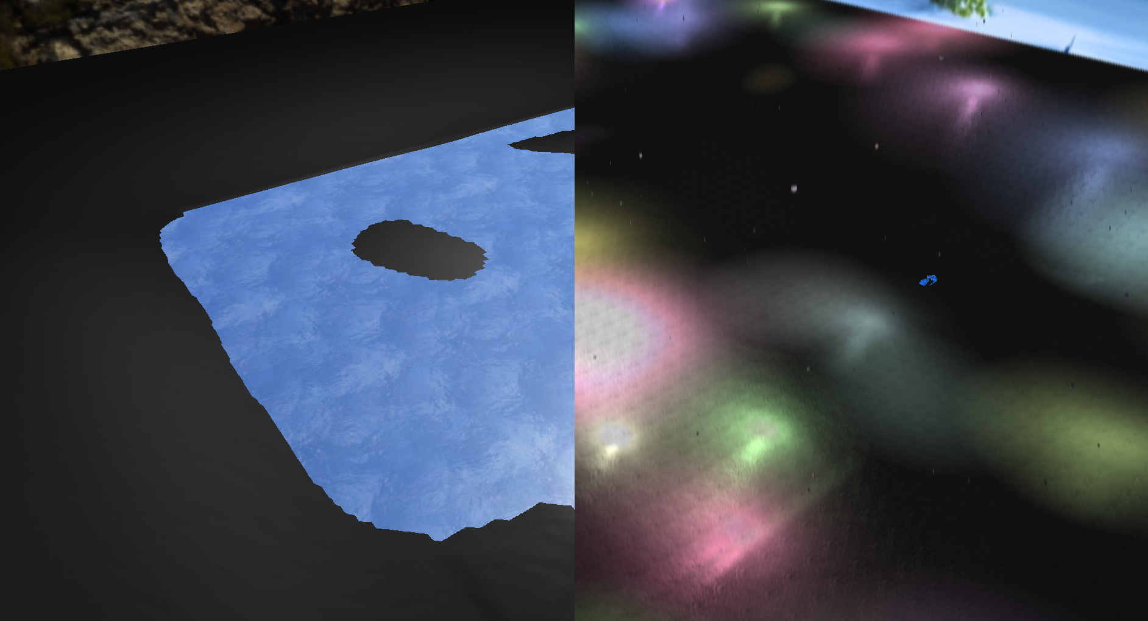

The dragon is animated with skeletal animation. It flies smoothly around the scene between set points by interpolating the previous and next point along with the time it should take between them.

This scene applies a gaussian blur effect after the landscape, snow, and lights have been drawn but before the animated dragon has been drawn so it contrasts with the rest of the scene.

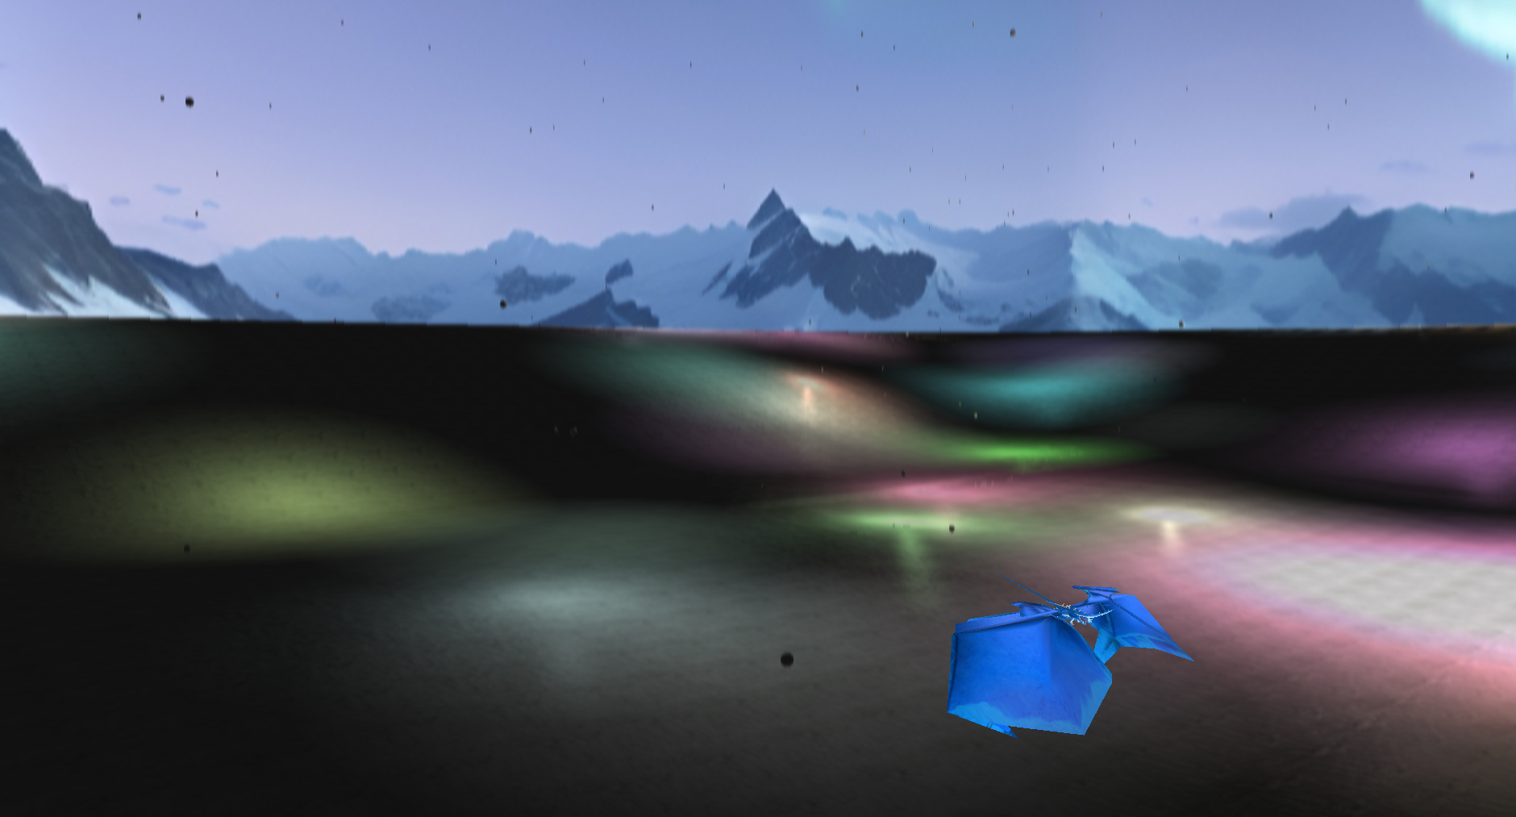

The water is partially transparent allowing you to see some of the texture beneath while also reflecting the skybox around the scene.

This scene uses a single area light representing the sun which makes use of ambient, diffuse, and specular values that can be changed and makes use of the normal map used by the ground texture.

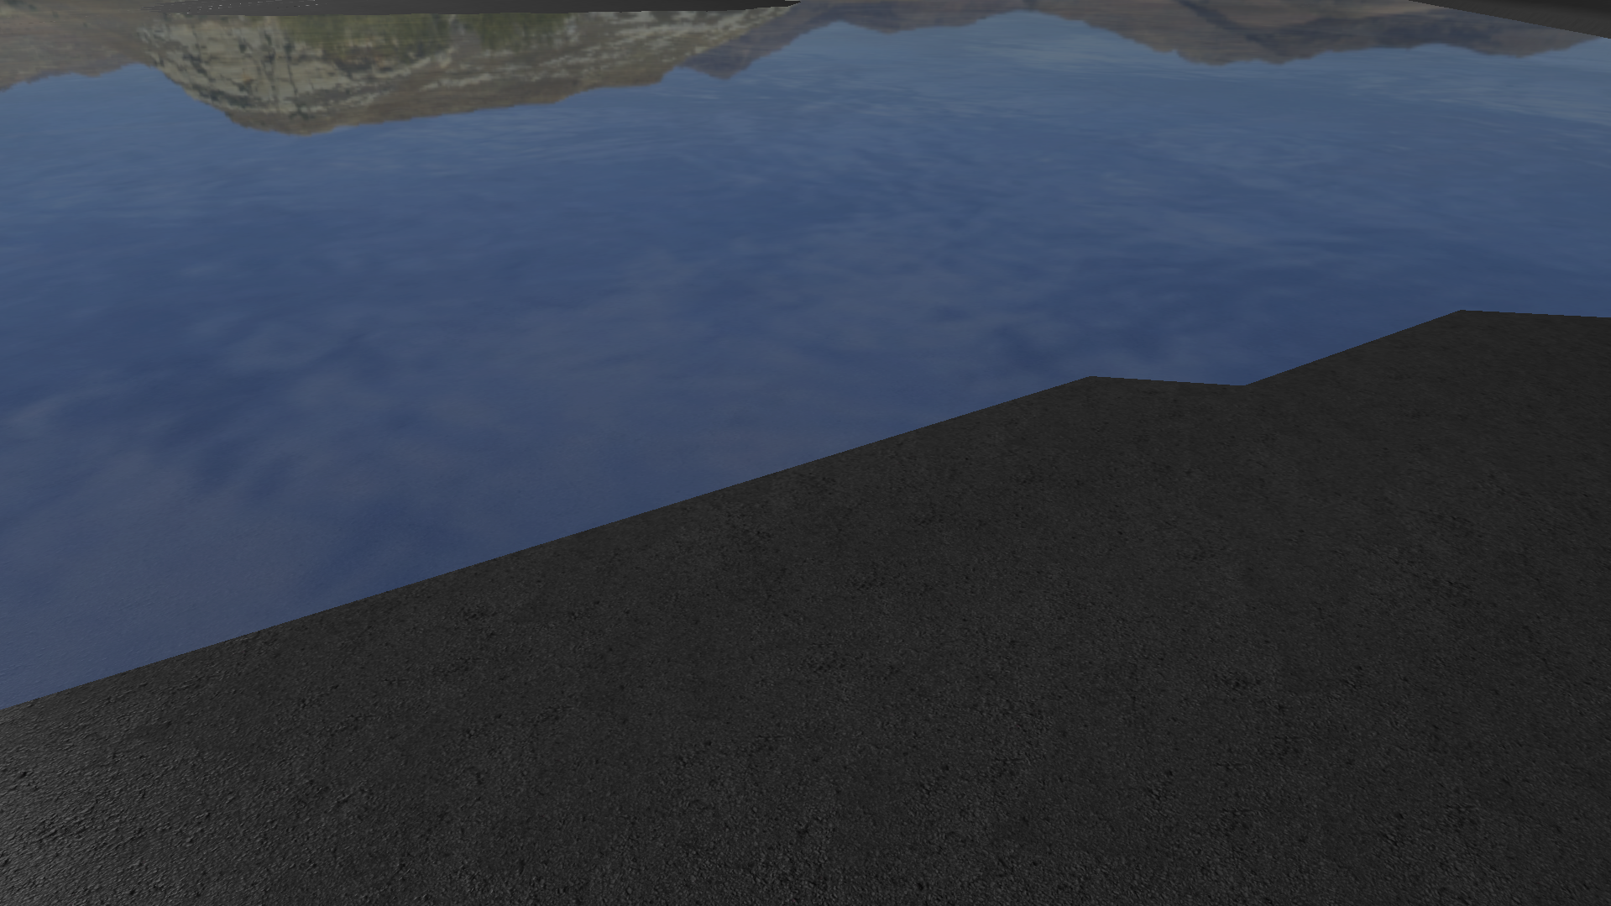

This transition effect slowly fills up more and more of the screen with random colours for 2.5 seconds. At 2.5 seconds, the screen is entirely covered and the scene is switched before the effect fades back out for the next 2.5 seconds. This effect is handled by a shader that is switched on in the final present scene function only during the transition and the time spent in transition is passed in for the shader to generate the random noise based on. This is enabled by the previous steps in the pipeline all eventually placing themselves into the same frame buffer, even though both scenes use a different buffer pipeline to enable deferred rendering in the winter scene, and this allows for effects like this transition or the previous split screen to take place.

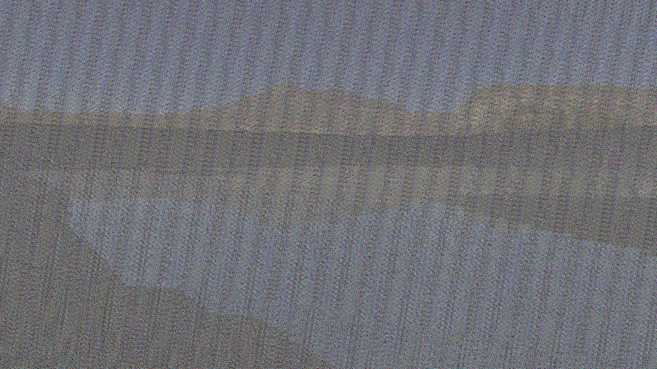

In the winter scene, the lower ground has a footprint texture that doesn’t appear near the top. Multiple textures and their normals are blended using the y value to show the lower ground appearing more walked on.

